**OFFICIAL COORDINATION REQUEST FOR**

**NON-ROUTINE OPERATIONS AND MAINTENANCE**

**COORDINATION TITLE-** 24BON008 MOC Bradford Island B-Branch LPS Handrail Work Over Water

**COORDINATION DATE-** 02/20/2024

**PROJECT-** Bonneville Lock & Dam

**RESPONSE DATE-** 02/28/2024

**Description of the problem—**A contractor will be installing a railing alongside a walkway over the B-Branch Fishway to allow for safe inspection and monitoring of the new B-Branch Lamprey Passage System (LPS). Delivery of the railing by a subcontractor has been delayed until the first week of March, after the fishway is watered up. The contractor will require three days for installation following delivery of materials. The nature of this work will involve drilling into concrete with hand tools producing noise over the fishway. This constitutes work that conflicts with section 2.1.3 of the 2023 FPP as work will occur directly over the fishway.

Per the 2023 FPP BON Section 2.1.3: “Research, non-routine maintenance, fish-related activities, and construction will not be conducted within 100' of any fishway entrance or exit, within 50' of any other part of the adult fishway, or directly in, above, or adjacent to any fishway, unless coordinated with FPOM or FFDRWG by the Project, District Operations and/or Planning or Construction office. Alternate actions will be considered by District and Project biologists in conjunction with the regional fish agencies on a case-by-case basis.”

The option to begin this work prior to the refilling of the Bradford Island B-Branch fishway is not possible due to the lengthy shipping and delivery timelines. Furthermore, this installation of the railing cannot be delayed until the next dewatering period due to the requirement of fish biologists to inspect the LPS systems during passage season and the major safety hazard a lack of guardrails poses.

**Type of outage required**: none

**Impact on facility operation**: none

**Dates of impacts/repairs**: March 4-8

**Length of time for repairs**: The contractor requires 3 days to complete installation and the dates of impact will be 4 days to allow for some flexibility.

**Analysis of potential impacts to fish**:

1. 10-year average passage during the period of impact for adults and juveniles listed species, as appropriate for the proposed action and time of year:

Adult Spring Chinook and Steelhead migrating upriver will be the main groups of fish who are likely to be impacted by this work. Numbers of fish passing Bonneville for the month of March are shown in the graph below. Ten-year averages compared to 2023 adult fish passage counts for Bonneville indicate that adult Spring Chinook passage varies between 0 and single digits during the scheduled work period. Adult Steelhead passage through Bonneville occurs on average earlier and in greater numbers compared to Spring Chinook, although Steelhead passage is below 30 fish per day for the scheduled work period. It should be noted that the Bonneville counts for this timeframe would be total numbers of fish passing through the dam, not necessarily just for this particular 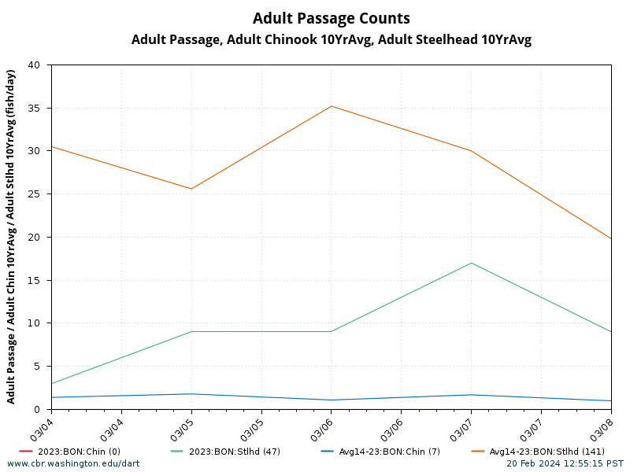fishway (Bradford Island B-Branch).

1. Statement about the current year’s run (i.e., higher or lower than 10-year average):

Because the 2024 adult fish passage season has not yet begun, comparison will be made between the 2023 run and the 2014-2023 10-year average.

Spring Chinook-Too early to determine the condition of the 2024 run. However, based on WDFW’s Forecast Report, Spring Chinook lower river totals are forecasted to be 84,600, and total Spring Chinook numbers are forecasted to be similar to 2023’s, at 205,600.

Steelhead-Currently trending above average compared to 2023 passage numbers, 4-year and 10-year averages.

1. Estimated exposure to impact by species and age class (i.e., number or percentage of run exposed to an impact by the action):
   1. Juveniles do not use this area in significant numbers, nor are quantifiable numbers of juveniles present at Bonneville during this time.
   2. Refer to Figures 1 and 2 for historical run timing for Spring Chinook (Figure 1) and Steelhead (Figure 2) passage at Bonneville Lock & Dam. Both runs are expected to be minimally affected during the March work 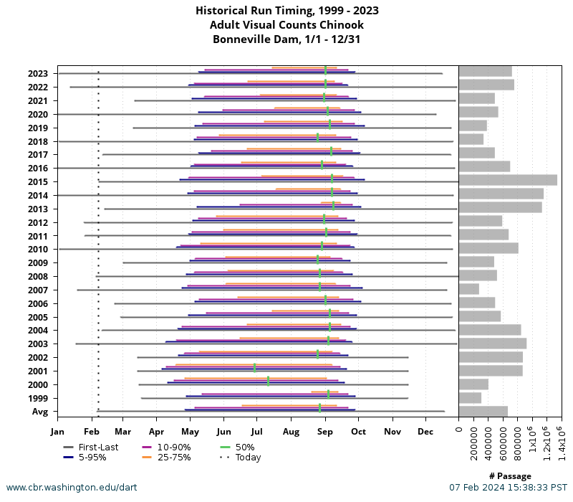period.

**Figure 1**. Historical run timing for adult Chinook passage at Bonneville

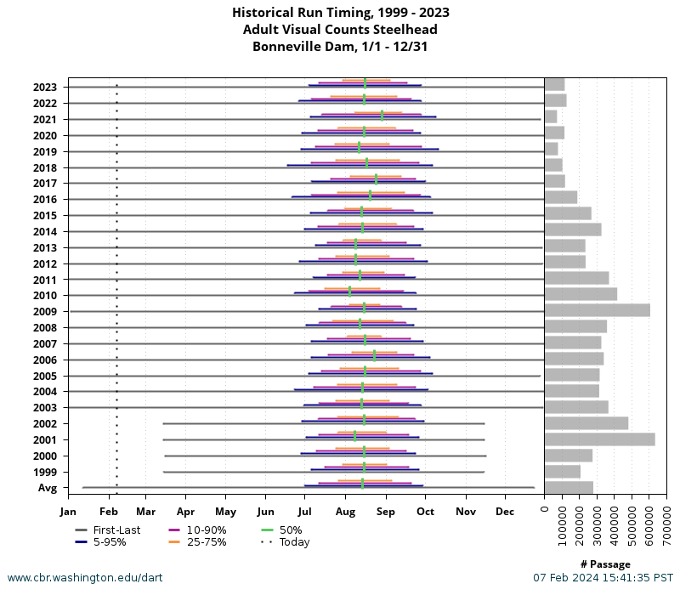

**Figure 2**. Historical run timing for adult Steelhead passage at Bonneville.

1. Type of impact by species and age class (increased delay, exposure to predation, exposure to route of higher injury/mortality rate, exposure to higher TDG, etc.):
   1. Adult Spring Chinook and Steelhead could potentially be delayed if noise from this work disturbs the fishway or if drilling into the concrete leads to rubble falling into the fishway.

**Summary Statement-expected impacts on:**

Possible passage delays for Spring Chinook and Steelhead. As shown in Figures 1 and 2, Bonneville rarely sees significant numbers of Spring Chinook during the work period. Steelhead passage through Bonneville averages ~30fish/day during the work period of March 4-8. Therefore, potential impacts on these species are considered minimal. No impact is foreseen for other salmonid species, Bull trout, or Pacific lamprey.

**Comments from agencies**

**From:** Tom Lorz <lort@critfc.org>   
**Sent:** Wednesday, February 21, 2024 7:14 AM  
**To:** Madson, Patricia L CIV USARMY CENWP (USA) <Patricia.L.Madson@usace.army.mil>  
**Subject:** [Non-DoD Source] Re: FPOM Official Coordination: 24BON007 MFR Unit 7 Forced Outage and Oil Leak and 24BON008 MOC B-Branch LPS Handrail work over water

Try to drill the holes closest to the ladder later in the day.  Can they do all the drilling first or do that later in the day and do the rest of the work the other parts of the day?   Just trying to preform the work that is most likely to impact adults to a time that will have the least impact.

**Final coordination results**

Please email or call with questions or concerns.

Thank you,

Jaselyn Owens

Fish Biologist

jaselyn.a.owens@usace.army.mil

Patricia Madson

Columbia River Coordinator (acting)

[patricia.l.madson@usace.army.mil](mailto:patricia.l.madson@usace.army.mil)